Steps to Redeem Credits (Individual Brev Org Option)

Step 1: Please go to http://brev.nvidia.com and input your email to create an account.

Step 2: Create New Brev Org after setting up your account - Once you have created a Brev Account, please click where it says ‘undefined’ on the top right corner, then click ‘Create a new organization’ and then name your Brev Org. Once you click ‘create’ this will replace ‘undefined’ in the top right hand corner with the name of your new Brev Org.
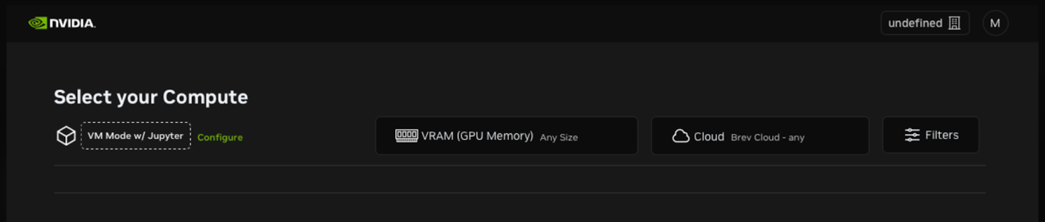
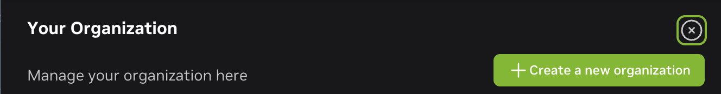
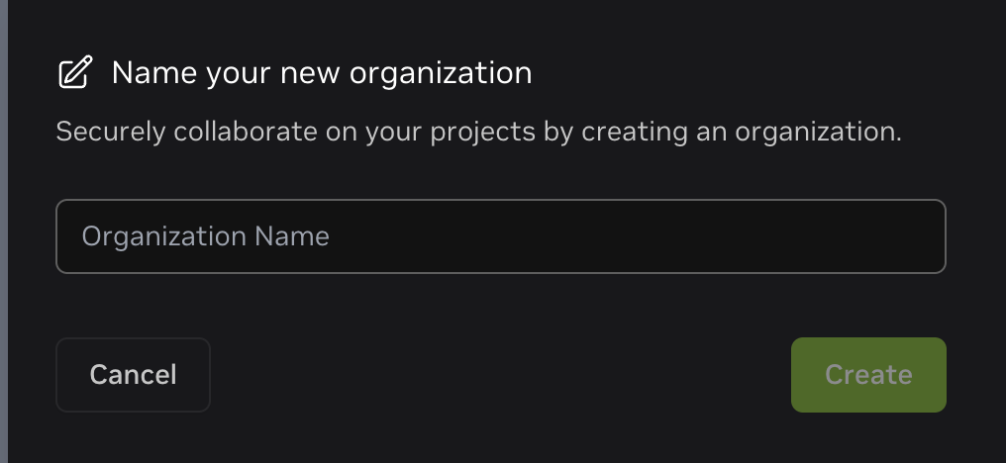

Step 3: Once you created and named your Brev organization - please go to the 'Billing' tab located at the top of the Brev console (as shown in the screenshot below).

Step 4: Once you have navigated to the ‘Billing’ tab, scroll down and click 'Redeem Code'. Then, enter the code you were provided in the 'Enter Code' field and click 'Redeem.' (Please ensure coupon code is all lower case).

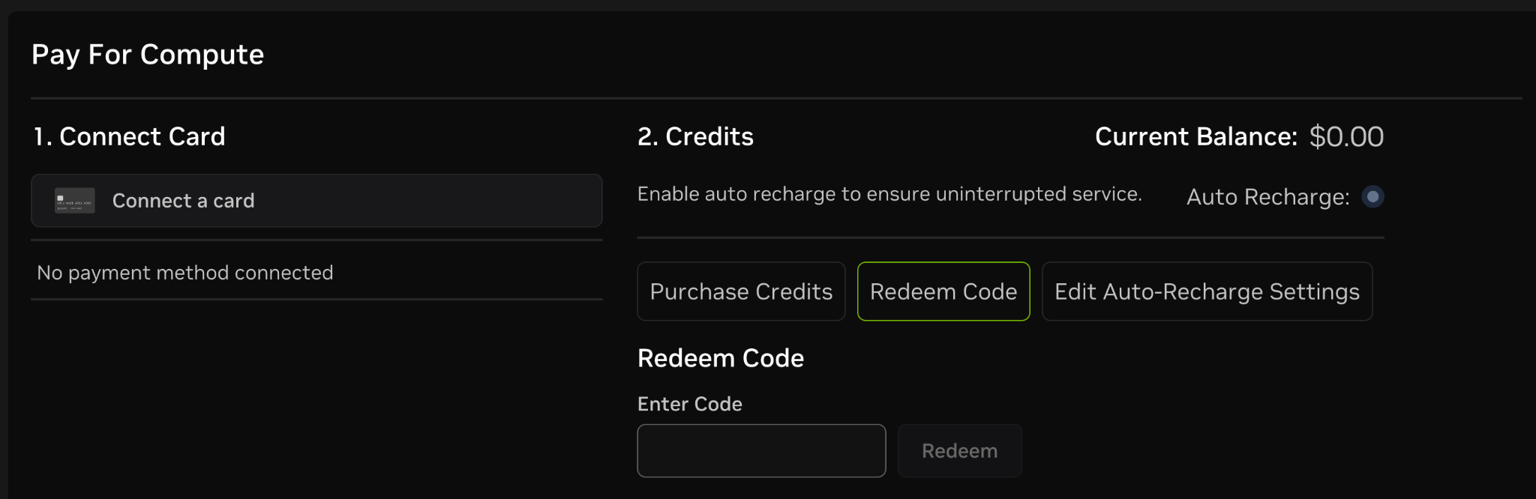

Brev Best Practices
Please Note: Brev instances are pay-by-the-hour.
This is important to understand to make the most of the credits you’ve been given. Make sure to stop instances when not being used. Any time the instance is running, it is using credits from your account at the typical running rate for your compute.
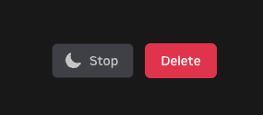
Stopping an instance incurs only a small charge per day. This pricing information is available via the Brev web interface.
example: running instance - costs depend on how the compute is configured
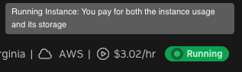
example: stopped instance - costs depend on how the compute is configured
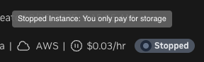

When choosing compute for an instance, make sure the instance is able to be started and stopped, as some providers do not allow stopping of instances. This warning will be displayed when creating an instance. For the best hackathon experience, pick an instance that can be restarted for maximum value from your credits.

Be aware of this warning shown below, that comes with some cloud providers. Some instances cannot be “stopped”, only deleted. We recommend choosing an option that can be restarted for the best user experience so you can save credits by stopping the instance when not actively using them.

